Eukaryotes and prokaryotes
- Eukaryotic cells have membrane-bound organelles and have genetic material contained in the nucleus
- An organelle is a part of a cell that carries out a specific function
- Plant and animal cells are examples of eukaryotic cells
- Eukaryotic cells are typically between 10-100 μm in size
- All eukaryotic cells have a nucleus, mitochondria, ribosomes, cytoplasm and a cell membrane. Plant cells also have a cell wall, vacuole and chloroplasts
- Mitochondria are the site of aerobic respiration which releases energy for cellular processes
- Ribosomes are the site of protein synthesis

- Prokaryotic cells do not contain membrane-bound organelles
- Prokaryotic cells are approximately 10 orders of magnitude smaller than eukaryotic cells
- Prokaryotic cells contain genetic material in small rings called plasmids, or in larger loops
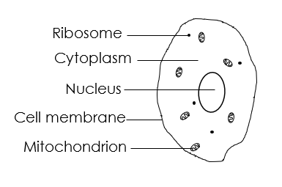
- Prokaryotic ribosomes are smaller than eukaryotic ribosomes
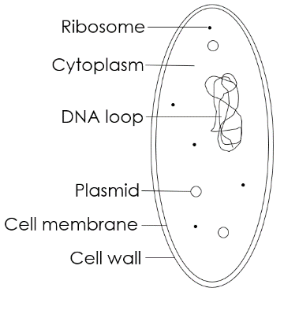
Growing microorganisms
- Petri dishes are used to produce cultures of bacteria and other micro-organisms
- Cultured bacteria are grown on a nutrient medium in controlled conditions
- Aseptic techniques must be used to prepare cultures to prevent contamination of the culture and the growth of harmful bacteria
- Petri dishes, inoculating loops and culture media must be sterilised before use. A flame can be used to sterilise equipment
- An inoculating loop is a piece of equipment used to transfer bacteria to the petri dish
- The lid of a Petri dish should be partially secured with tape to ensure bacteria cannot escape but conditions remain aerobic
- The Petri dish must be stored upside down to prevent condensation affecting bacterial growth
- In school laboratories, cultures should generally be incubated at 25 °C to prevent the growth of harmful bacteria
- A cotton wool swab can be used to transfer a sample to a Petri dish to investigate bacterial growth
- Bacteria on a Petri dish divide rapidly whilst the nutrient supply is rich. Every time the bacteria reproduce, the number doubles. The total number of bacteria can be calculated using the following formula:
Final number of bacteria = Initial number of bacteria x 2 ^{number of divisions}

Microscopy
- Microscopy is the field of using microscopes to view samples that cannot be seen with the naked eye
- Light microscopes allow us to see the largest organelles, including the nucleus, cell membrane, cell wall and cytoplasm. A stain is often used to make the organelles clearer
- The parts of a light microscope include the eyepiece lens, objective lenses, stage, coarse focusing wheel, fine focusing wheel, light/mirror
- A sample used with a light microscope must be very thin to allow light to pass through
- The total magnification of a microscope can be calculated using the following equation:
Total magnification = Objective lens x eyepiece lens
- Electron microscopes have a greater magnification and resolution than light microscopes. They are much more expensive than light microscopes
- Magnification is the number of times larger an image is than the object
- Resolution is the ability to distinguish between two points
- Electron microscopes allow are to see more organelles and study cells in greater detail
- Magnification can be calculated using the following equation:
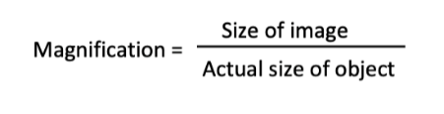
- A scale bar can be used to calculate the magnification of an irregular object
- Magnification does not have a unit because it is a ratio

Transport of substances
- Diffusion is the spreading out of particles, of a gas or liquid, resulting in net movement from an area of high concentration to low concentration

- In gas exchange, oxygen and carbon dioxide diffuse between the alveoli and the blood
- The rate of diffusion is increased by:
- an increase in temperature
- an increase in the difference in concentrations (concentration gradient)
- a greater surface area
- Unicellular organisms have a relatively high surface area to volume ratio allowing for sufficient transport of all required substances
- Large, multicellular organisms have adaptations to increases the surface area to volume ratio to allow for efficient exchange of substances

- Osmosis is the diffusion of water from a dilute solution to a concentrated solution through a partially permeable membrane

- A partially permeable membrane is a membrane that lets particular substances pass through it, either into or out of the cell
- A hypertonic solution is one in which the external solution has a higher concentration of solute than the cell. Water always moves out of a cell that is placed in a hypertonic solution, causing the cell to shrivel or become flaccid
- Tissue placed in hypertonic solutions decreases in mass
- A hypotonic solution is one in which the external solution has a lower concentration of solute than the cell. Water always moves into a cell that is placed in a hypotonic solution, causing the cell to swell or become turgid
- Tissue placed in hypotonic solutions increases in mass
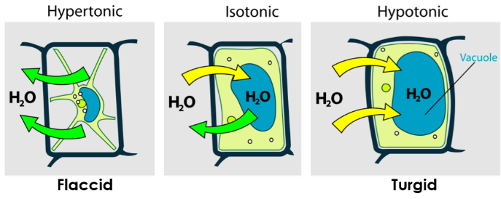
- An isotonic solution is one in which the external solution has the same concentration of solute as the cell. Water will not move in or out of cells placed in an isotonic solution so their size will stay constant

- Guard cells open and close due to the movement of water by osmosis
- The mass of plant tissue can be measured before and after being placed in a solution of known concentration to calculate the percentage change in mass due to osmosis

- Active transport moves substances from a more dilute solution to a more concentrated solution, requiring energy from respiration
- Active transport works against the concentration gradient
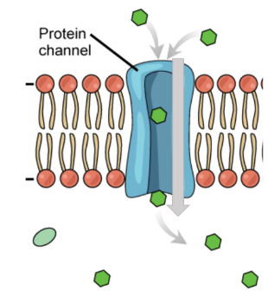
- Active transport is used in root hair cells to absorb mineral ions from the soil that are essential for plant growth

Cell division and differentiation
- Both eukaryotic and prokaryotic cells undergo cell division
- Cells increase in number by dividing into two
- The eukaryotic cell cycle contains a growth phase where the cell grows to double sub-cellular structures (such ribosomes and cell membrane) and DNA, then the cell splits into two during mitosis
- The length of time in a certain stage of the cell cycle can be calculated using the following formula: 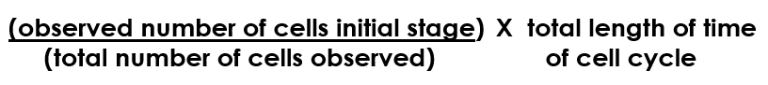
- The mass of DNA in a cell doubles during the growth phase of the cell cycle
- During mitosis DNA (arranged into chromosomes) is pulled to separate ends of the cell ready for division
- The final part of the cell cycle is when the cell membrane splits to produce two identical daughter cells
- Mitosis is used by eukaryotic organisms for growth and repair and by those that reproduce asexually
- Mitosis does not occur in prokaryotic cells because they do not possess a nucleus

- Checkpoints in the cell cycle control the rate of cell division
- Cancer is caused by uncontrolled cell division
- A tumour is a mass of cells caused by uncontrolled cell division
- Benign tumours are a mass of cells contained in one area
- Malignant tumours are formed of cancer cells that invade other tissues and spread around the body where they form secondary tumours
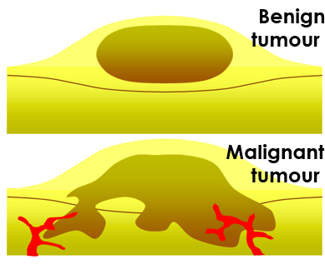

- A risk factor is a gene or lifestyle choice that can increase the likelihood of a person developing a disease
- Lifestyle risk factors for cancer include poor diet, lack of exercise, smoking, UV exposure
- Genetic risk factors for cancer include gene mutations

- Specialised cells arise from stem cells
- Stem cells are cells that are capable of differentiating into other types of cell
- When a cell differentiates, it acquires specific structures needed for that cell type
- Most animal cells differentiate at an early stage of development
- Embryonic stem cells can differentiate into all human cell types
- Adult bone marrow contains stem cells that can differentiate into different types of blood cell
- Embryonic stem cells can be used to study and treat diseases. There are religious and ethical objections to using embryonic stem cells in scientific research
- Plants contain meristem tissue at the tips of shoots and roots that retains the ability to differentiate throughout a plant’s life

